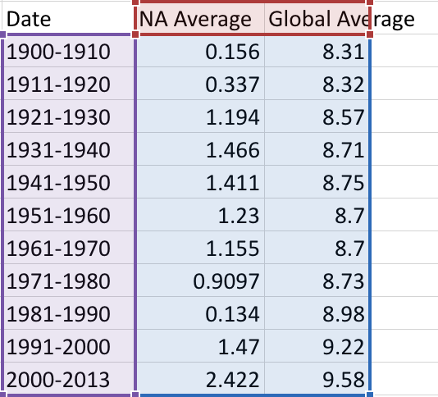

* The table lists the NA average temperature with the Global temperatures in 10 year increments.

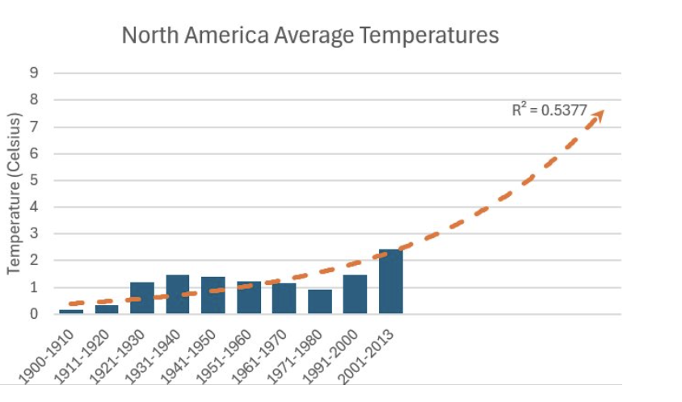

* The 1980s were removed because they were a large outlier due to the polar vortex that caused record-low temperatures.

- 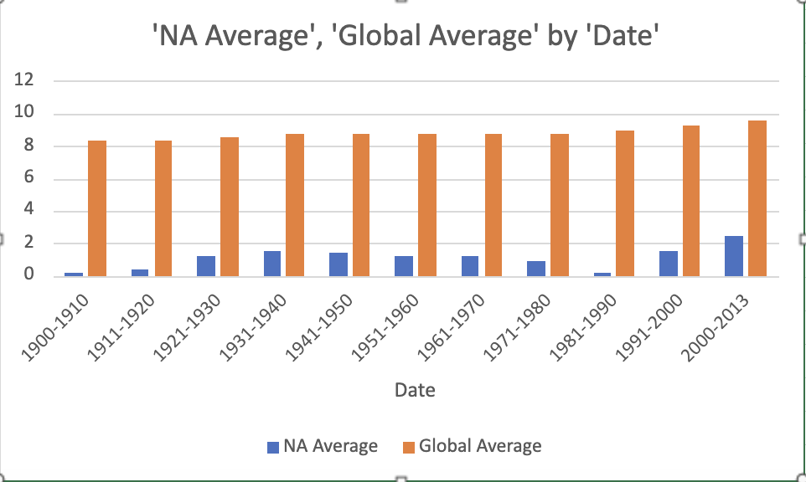This graph explains the North American Average temperature with the global average temperature.